Assignment No: 1

Q1. Wap to demonstrate ternary operator define a variable marks .Ask its value from user and using ternary operator check if marks > 40 store "Pass" in result variable else store "Fail".

Program:

import java.util.Scanner;

public class que1 {

public static void main(String[] args) {

Scanner s =new Scanner(System.***in***);

System.***out***.println("Enter your marks less than 100:");

float marks=s.nextFloat();

String result=(marks>40)?"pass":"fail";

System.***out***.println(result);

}

}

Output

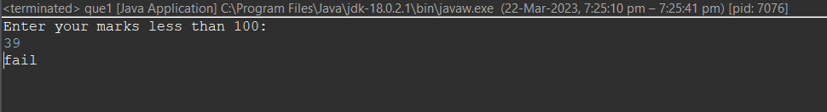

Q 2. Using ternary check if number entered by user is positive or negative.  
In case number is positive store "Positive number" else store negative number to Result variable.

Program:

import java.util.Scanner;

public class que2 {

public static void main(String[]args)

{

Scanner s = new Scanner(System.***in***);

System.***out***.println("Enter a Number:");

int num = s.nextInt();

if(num > 0)

System.***out***.println("Positive Number");

else if(num < 0)

System.***out***.println(" Neagative Number");

else

System.***out***.println(" Number Is 0");

}

}

Output:

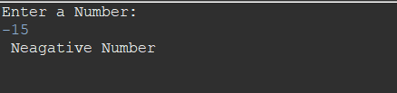

Q 3. WAP to ask name ,age and salary of an employee and print on console.

Program:

import java.util.Scanner;

public class que3 {

public static void main(String[] args)

{

Scanner s = new Scanner(System.***in***);

System.***out***.println("Enter your name: ");

String name = s.nextLine();

System.***out***.println("Enter your age: ");

int age = s.nextInt();

System.***out***.println("Enter your salary: ");

float salary=s.nextFloat();

System.***out***.println("Employee dateils are: ");

System.***out***.println("Name: "+name);

System.***out***.println("Age: "+age);

System.***out***.println("Salary: "+salary);

}

}

Output:

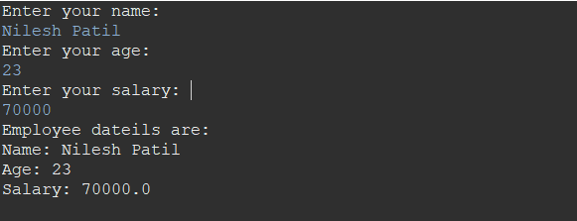

Q 4. Wap  that ask two numbers from user and print greater number among two .

Program:

import java.util.Scanner;

public class que4 {

public static void main(String[]args){

Scanner s=new Scanner(System.***in***);

System.***out***.println("Enter 1st No");

int a=s.nextInt();

System.***out***.println("Enter 2nd NO");

int b=s.nextInt();

if (a>b)

System.***out***.println(a+ " is Greater");

else if(a==b)

System.***out***.println("Bothe numbers are equal");

else

System.***out***.println(b+ " is greater");

}

}

Output:

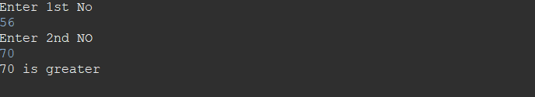

Q 5. Wap to ask product name and price of product from user and calculate discount i.e if price > 2000 then discount is 10 percent of price else discount is 7 % of price.

Program:

import java.util.Scanner;

public class que5 {

public static void main(String []args)

{

Scanner s = new Scanner(System.***in***);

System.***out***.println("Enter product name: ");

String product_name= s.nextLine();

System.***out***.println("Enter product price: ");

float product_price = s.nextFloat();

float discount=0;

if (product_price>2000)

{

discount=(product_price*10)/100;

System.***out***.println("After getting 10% discount,discount is: "+discount);

}

else {

discount=(product_price*7)/100;

System.***out***.println("After getting 7% discount,discount is: "+discount);

}

}

}

Output:

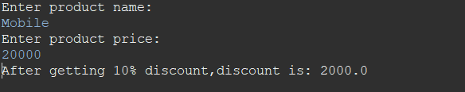

Q 6.Wap to swap two numbers.

Program:

import java.util.Scanner;

public class que6 {

public static void main(String[]args)

{

System.***out***.println("Enter The Numbers:");

Scanner s=new Scanner(System.***in***);

int a=s.nextInt();

int b=s.nextInt();

int c;

System.***out***.println("Numbers Before Swapping:" + a +" "+ b );

c = a;

a = b;

b = c;

System.***out***.println("Numbers After Swapping:" + a + " "+ b);

}

}

Output:

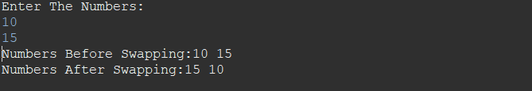

Q7. How to swap two numbers without using a third variable?

Program:

import java.util.Scanner;

public class que7 {

public static void main(String[]args)

{

System.***out***.println("Enter the value of a & b:");

Scanner s=new Scanner(System.***in***);

int a=s.nextInt();

int b=s.nextInt();

System.***out***.println("Numbers Before Swapping:" + a + " " + b);

a = a+b;

b = a-b;

a = a-b;

System.***out***.println("Numbers After Swapping:" + a + " " + b);

}

}

Output:

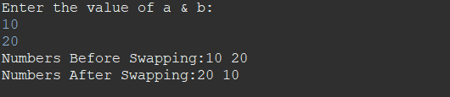

Q 8. Wap to check is number is even or odd.

Program:

import java.util.Scanner;

public class que8 {

public static void main(String[]args)

{

Scanner s = new Scanner(System.***in***);

System.***out***.println("Enter no");

int a=s.nextInt();

String result = (a%2==0)?"Even no":"Odd no";

System.***out***.println(result);

}

}

Output:

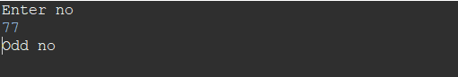

Q 9   A school has following rules for grading system:  
 a. Below 25 - F  
 b. 25 to 45 - E  
 c. 45 to 50 - D  
 d. 50 to 60 - C  
 e. 60 to 80 - B  
 f. Above 80 - A  
 Ask user to enter marks and print the corresponding grade.

Program:

import java.util.*;

public class que9 {

public static void main(String[]args) {

Scanner sc = new Scanner(System.***in***);

System.***out***.println("Enter your Marks");

int marks = sc.nextInt();

if(marks>=1&& marks<=25)

System.***out***.println("F");

else if(marks>25 && marks<=45)

System.***out***.println("E");

else if(marks>45 &&marks<=50)

System.***out***.println("D");

else if(marks>50 && marks<=60)

System.***out***.println("C");

else if(marks>60&& marks<=80)

System.***out***.println("B");

else if(marks>80 && marks<=100)

System.***out***.println("A");

else

System.***out***.println("No valid");

}

}

Output:

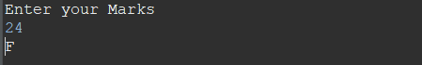

Q 10. Wap to check greater number among three numbers.

Program:

import java.util.Scanner;

public class que10 {

public static void main(String[]args)

{

Scanner s=new Scanner(System.***in***);

System.***out***.print("Enter 1st no:");

int x =s.nextInt();

System.***out***.print("Enter 2nd no:");

int y =s.nextInt();

System.***out***.print("Enter 3rd no:");

int z =s.nextInt();

if(x > y && x > z)

System.***out***.println("Largest Number is:" +x);

else if(y>z)

System.***out***.println("Largest Number is:" +y);

else

System.***out***.println("Largest Number is:" +z);

}

}

Output:

